**Question1:**

**What is from element? How it is used? Create a form, using <form> element and use all html input elements including the following input types.**

**Color, date, datetime-local, email, month, number, range, search, radiobutton /**

**multiple radiobuttons, Button, checkbox, checklist, dropdown, textarea**

**(maxlength, minlength), password, range, reset, submit, url.**

Answer:

The <form> element is a container for different types of input elements, such as:

text fields, checkboxes, radio buttons, submit buttons, etc.

The <form> element can contain one or more of the following form elements:

<input>, <textarea>, <button>, <select>, <option>, <optgroup>, <fieldset>, <label>,

<output>.

<input> tag specifies an input field where the user can enter data.

The <input> element is the most important form element.

The <input> element can be displayed in several ways, depending on the type

attribute.

The different input types are as follows:

• <input type="button">

• <input type="checkbox">

• <input type="color">

• <input type="date">

• <input type="datetime-local">

• <input type="email">

• <input type="file">

• <input type="hidden">

• <input type="image">

• <input type="month">

• <input type="number">

• <input type="password">

• <input type="radio">

• <input type="range">

• <input type="reset">

• <input type="search">

• <input type="submit">

• <input type="tel">

• <input type="text"> (default value)

• <input type="time">

• <input type="url">

• <input type="week">

**Code:**

*<!DOCTYPE>*

*<html>*

*<head>*

*<title>HTML Form</title>*

*</head>*

*<form>*

*<body>*

*<label for="fname">First name:</label>*

*<input type="text" id="fname" name="fname">*

*<label for="email"> Email Address:</label>*

*<input type="email" id="email" name="email">*

*<label for="Mycolor">Favourite color:</label>*

*<input type="color" id="Mycolor" value="red">*

*<label for="date">Date Today:</label>*

*<input type="date">*

**Web Page:**



**Code:**

*<label for="month">Month is:</label>*

*<input type="month"><br><br>*

*<label for="dateTime"> Local date and time:</label>*

*<input type="datetime-local"><br><br>*

*<label for="number">The Number is:</label>*

*<input type="number" id="number"><br><br>*

*<label for="range">The Range is:</label>*

*<input type="range" id="range"><br><br>*

*<lable for="search">The search engine is:</label>*

*<input type="search" id="search" name="search"><br><br>*

*<!--FOOD SELECTION-->*

*<p>Please select your favourite food</p>*

*<input type="radio" id="Rosh" name="fav_food" value="Rosh">*

*<lable for="Rosh">ROSH</label><br>*

*<input type="radio" id="Shinwari Karahi" name="fav_food" value="Shinwari Karahi">*

*<lable for="Rosh">SHINWARI KARAHI</label><br>*

*<input type="radio" id="Burgers" name="fav_food" value="Burgers">*

*<lable for="Rosh">BURGERS</label><br>*

*<input type="radio" id="Sajji" name="fav_food" value="Sajji">*

*<lable for="Rosh">SAJJI</label><br>*

*<!--CHECKBOXES-->*

*<p>Select subjects in which you find interest</p>*

*<input type="checkbox" id="maths" name="maths" value="maths">*

*<label for="maths">HRM</label>*

*<input type="checkbox" id="astrophysics" name="science" value="astrophysics">*

*<label for="maths">astrophysics</label>*

*<input type="checkbox" id="arts" name="arts" value="arts">*

*<label for="maths">ARTS</label>*

*<input type="checkbox" id="history" name="history" value="history">*

*<label for="maths">DBMS</label>*

*<input type="checkbox" id="mass com" name="mass com" value="mass com">*

*<label for="maths">Mechatronics</label>*

*<label for="homepage">Homepage is:</label>*

*<input type="url" id="homepage" name="homepage">*

*<label for="pwd"> Password is:</label>*

*<input type="password" id="pwd" name="pwd">*

*<p>Select elements of your choice</p>*

*<select name="place" id="place">*

*<label for="place">Choose place for trip:</label>*

*<option value="Balochistan">Quetta</option>*

*<option value="Balochistan">Loralai</option>*

*<option value="Sindh">Karachi</option>*

*<option value="Balochistan">Khuzdar</option>*

*<option value="Punjab">Lahore</option></select> <br><br>*

*<p><label for="feedback">Feedback</label></p>*

*<textarea id="feedback" name="feedback" rows="2" cols="50"*

*maxlength="50" minlength="5">Dbms is my favorite subject.*

*I'd like to pursue my Masters degree in DBMS.</textarea><br><br>*

*<label for="animal">Animals from datalist are:</label>*

*<input list="animals" name="animal" id="animal">*

*<datalist id="animals">*

*<option value="Goats">*

*<option value="Camel">*

*<option value="Sheeps">*

*<option value="Aligator">*

*<option value="Turtle">*

*</datalist><br><br>*

*<p>Progress of your downloading file </p>*

*<label for="file">Downloading progress:</lable>*

*<progress id="file" value="40" max="100">40%</progress><br><br>*

*<input type="submit" value="SUBMIT">&nbsp;&nbsp;&nbsp;&nbsp;&nbsp<input*

*type="reset" value="RESET"><br><br>*

*</form>*

*</body>*

*</html>*

**Web Page:**

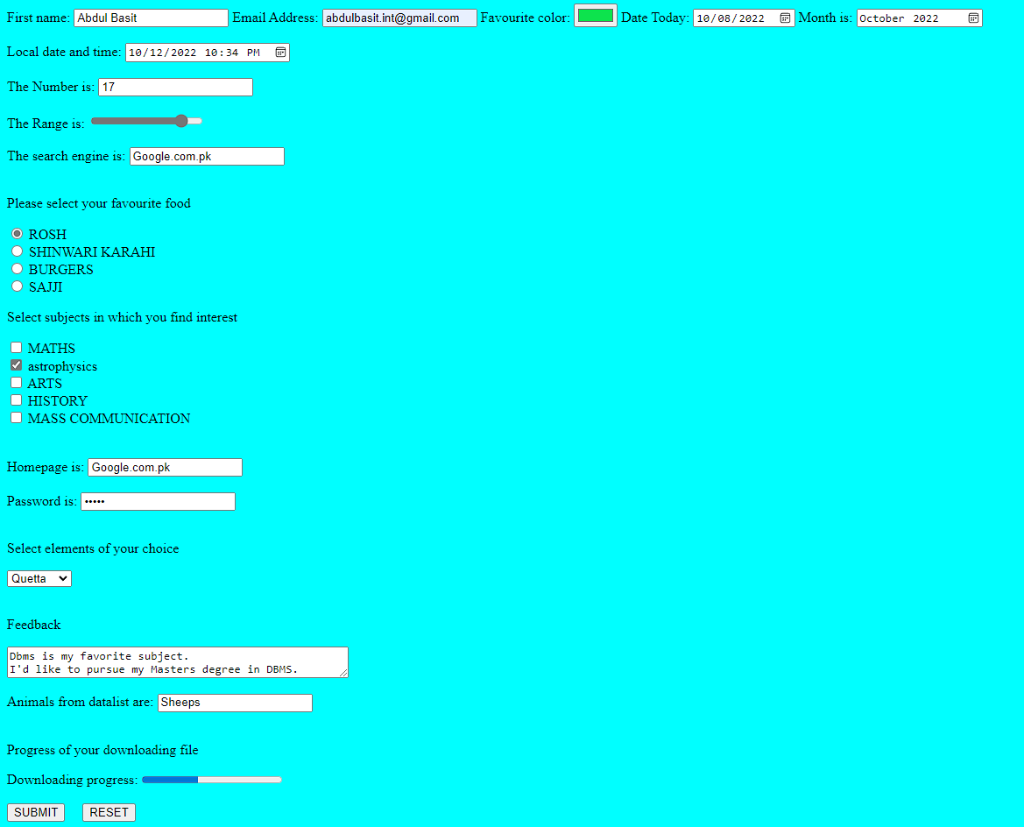

**QUESTION 2**

**While using input types, what is the role of the following attributes? Srcset, readonly attribute, disabled attribute, autocomplete attribute, novalidate, autofocus, placeholder, required, write code and use them*.***

**Srcset Attribute**

The HTML srcset attribute is used to specifies the URL of an image to use in different situations. When <source> is used in <picture> it is required.

**Readonly Attribute**

The Boolean readonly attribute, when present, makes the element not mutable, meaning the user cannot edit the control If the readonly attribute is specified on an input element, because the user cannot edit the input, the element does not participate in constraint validation.

<label for="fname">First name:</label><br>

<input type="text" id="fname" name="fname">

id="name"value="Abdul Basit" readonly>



**Disabled Attribute**

The Boolean disabled attribute, when present, makes the element not mutable, focusable, or even submitted with the form. The user can neither edit nor focus on the control, nor its form control descendants. If the disabled attribute is specified on a form control, the element and its form control descendants do not participate in constraint validation.

<label for="fname">First name:</label>

<input type="text" id="fname" name="fname">

id="name" placeholder="insert first name"><br><br>

<label>Last Name: </label>

<br>

<input type="text" name="lname"

id="name" disabled

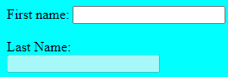

**No-validate:** It indicates that form is not validate to submit.

**Disabled:** it indicates that field is disabled.

**Autocomplete:** The autocomplete attribute specifies whether a form or an input field should have autocomplete on or off. Autocomplete allows the browser to predict the value. When a user starts to type in a field, the browser should display options to fill in the field, based on earlier typed values.

**Required:** it indicates that data must be entered in field.

**Autofocus:** it automatically focuses on respective field.

**Placeholder:** The placeholder attribute specifies a short hint that describes the expected value of an input field (e.g. a sample value or a short description of the expected format).

**Code:**

*<!--novalidate-->*

*<label for="email">Enter your email:</label>*

*<input type="email" id="email" name="email"><br><br>*

*<input type="submit"><br><br>*

*<!--required-->*

*<label for="username">Username:</label>*

*<input type="text" id="username" name="username" required>*

*<input type="submit"><br><br>*

*<!--autofocus-->*

*<label for="fathername">Father name:</label>*

*<input type="text" id="fathername" name="fathername"autofocus><br><br>*

*<!--autocomplete-->*

*<label for="Marks">Marks:</label>*

*<input type="grade" id="Marks" name="Marks"*

*autocomplete="off"><br><br>*

*<!--disbled-->*

*<label for="middlename">Middle name:</label>*

*<input type="text" id="middlename" name="middlename"*

*disabled><br><br>*

**Web Page:**

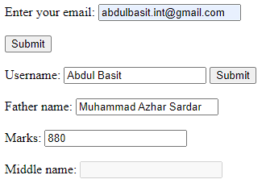

**Question:3**

**Understand the use of elements; mail link, telephone link,<article>, <footer>, <section>, picture element, audio element, video element, their controls and supported formats**.

Answer:

**Mail link:** HTML <a> tags allow you to send an email to an email address. You will use mailto: email address and href attribute with <a> tags to create an email.

**Syntax:**

<a href = "mailto: abc@example.com">Send Email</a>

HTML Example:

*<!DOCTYPE html>*

*<html>*

*<head>*

*<title></title>*

*</head>*

*<body>*

*<p> My Email: <a href ="mailto:abdulbasit,int@gmail.com">abdulbasit,int@gmail.com</a></p>*

*</body>*

*</html>*

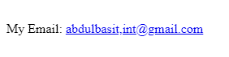

**Telephone link:** <input> elements of type tel are used to let the user enter and edit a telephone number.

**Code:**

*<!DOCTYPE html>*

*<html>*

*<head>*

*<meta charset="utf-8">*

*<meta name="viewport" content="width=device-width, initial-scale=1">*

*<title></title>*

*</head>*

*<body>*

*<p> Cell Number: <a href="tel:+92 3310371478">+92 3310371478</a></p>*

*</body>*

*</html>*

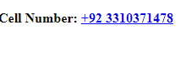

**<article>:** The <article> tag specifies independent, self-contained content. An article should make sense on its own and it should be possible to distribute it independently from the rest of the site.

**Code:**

*<!DOCTYPE html>*

*<html>*

*<head>*

*<meta name="viewreport" content="width=device-width, initial-scale=1">*

*<style>*

*article{*

*margin: 10px;*

*padding: 5px;*

*border: dotted;*

*}*

*</style>*

*</head>*

*<body>*

*<div>*

*<article>*

*<p><b>1.A paragraph is a series of sentences that are organized and coherent, and are all related to a single topic. Almost every piece of writing you do that is longer than a few sentences should be organized into paragraphs.*

*</article>*

*<br><br>*

*<article>*

*<b>2. Elements of a Paragraph A paragraph is made up of a topic sentence, the developing details, and a concluding sentence. It is important to fully develop and discuss the topic of your paragraph. If your paragraph is only 2-3 sentences, there is a good chance that you have not developed it enough.*

*</article>*

*</p>*

*</div>*

*</body>*

*</html>*

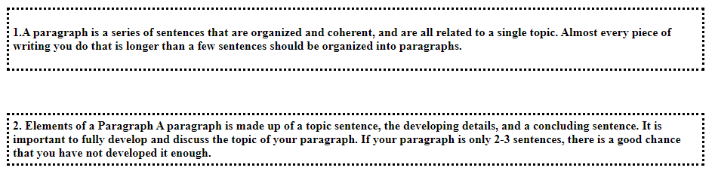

**<footer>:** The <footer> tag defines a footer for a document or section.

**Code:**

*<!DOCTYPE html>*

*<html>*

*<head>*

*<meta name="viewreport" content="width=device-width, initial-scale=1">*

*<style>*

*article{*

*margin: 10px;*

*padding: 5px;*

*border: dotted;*

*}*

*</style>*

*</head>*

*<body>*

*<div>*

*<br><br>*

*<article>*

*<b>2. Elements of a Paragraph A paragraph is made up of a topic sentence, the developing details, and a concluding sentence. It is important to fully develop and discuss the topic of your paragraph. If your paragraph is only 2-3 sentences, there is a good chance that you have not developed it enough.*

*</article>*

*</p>*

*<footer>*

*<p>Author: Abdul Basit</p>*

*<p> Email Address<a href="abdulbasit.int@gmail.com">abdulbasit.int@gmail.com</a></p>*

*</footer>*

*</div>*

*</body>*

*</html>*

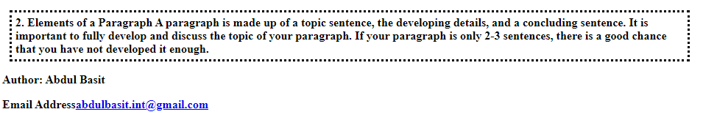

**Section:** The <section> tag defines a section in a document.

*<!DOCTYPE html>*

*<html>*

*<head>*

*<meta name="viewreport" content="width=device-width, initial-scale=1">*

*<style>*

*article{*

*margin: 10px;*

*padding: 5px;*

*border: dotted;*

*}*

*</style>*

*</head>*

*<body>*

*<div>*

*<h2> Section Element</h2>*

*<section>*

*<h3>First Section</h3>*

*</section>*

*<p><b>1.A paragraph is a series of sentences that are organized and coherent, and are all related to a single topic. Almost every piece of writing you do that is longer than a few sentences should be organized into paragraphs.*

*<section>*

*<br><br>*

*</section>*

*<b>2. Elements of a Paragraph A paragraph is made up of a topic sentence, the developing details, and a concluding sentence. It is important to fully develop and discuss the topic of your paragraph. If your paragraph is only 2-3 sentences, there is a good chance that you have not developed it enough.*

*</p>*

*</div>*

*</body>*

*</html>*

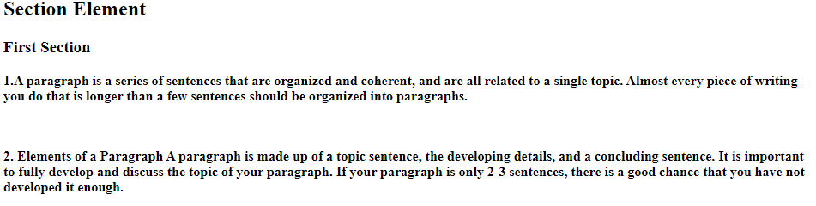

**Audio element:** The <audio> tag is used to embed sound content in a document, such as music or other audio streams.

**Code:**

*<!DOCTYPE html>*

*<html>*

*<head>*

*<title></title>*

*</head>*

*<body>*

*<audio controls>*

*<source src="trailer.mp3">*

*</body>*

*</html>*

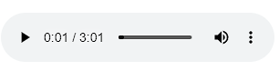

**Video element:** The <video> tag is used to embed video content in a document, such as a movie clip or other video streams.

*<!DOCTYPE html>*

*<html>*

*<head>*

*<title></title>*

*</head>*

*<body>*

*<video width="500" controls>*

*<source src="trailer.mp4">*

*</video>*

*</body>*

*</html>*



**Picture element:** The HTML <picture> element allows you to display different pictures for different devices or screen sizes.

*<!DOCTYPE html>*

*<html> <head>*

*<title></title>*

*</head>*

*<body>*

*<picture>*

*<source srcset="Quetta.jpg">*

*<img src="Quetta.jpg="Flower"*

*width="200"height="200">*

*</picture>*

*</body></html>*



**Question 4:**

**Explore and understand the CSS properties display, overflow, float, position, zindex, auto value for distance and make a simple drop-down menu using nav element.**

**CSS Overflow:**

When an element's content is too big to fit in the specified area, the overflow property specifies whether to clip it or add scrollbars.

The overflow property has the following values:

visible: Default. There is no clipping of the overflow. In this case, the content renders

outside the box of the element.

hidden: The overflow has been clipped, and the remaining content is hidden.

scroll: A scrollbar is added to view the remainder of the content after the overflow is

clipped.

auto: Like scroll, but only adds scrollbars when needed.

Syntax:

div {

overflow: hidden;

overflow: visible;

}

**CSS Display:**

Display determines whether an element is a block or inline element, as well as how its children are laid out, such as flow layout, grid, or flex.

An element's display property specifies its inner and outer display types. Flow layout is determined by the outer type; children's layout is determined by the inner type. In the CSS

Flexible Box Model specification, the detail of what happens when display: flex is declared is defined in detail.

Syntax

The CSS display property is specified using keyword values.

/* precomposed values */

display: block;

display: inline;

/* box generation */

display: none;

display: contents;

/* two-value syntax */

display: block flow;

display: inline flow;

**• CSS Float:**

You can use the float property to position and format content, such as floating an image

to the left of text.

There are four possible values for the float property:

left: Floats left of its container.

right: Float right of its container.

none: The element doesn't float (will appear exactly where it appears in the text). This is the default.

inherit: A child element inherits a parent's float value.

Syntax:

img {

//..float: none;

//.. float: left;

}

**CSS Z-index**

It is possible for elements to overlap when they are positioned. Stack order (placement

of an element in front, or behind, other elements) is specified by the z-index property.

There are two types of stack order: positive and negative:

Syntax:

img {

z-index: -1;

}

• **CSS Position:**

An element's position property specifies how it will be positioned.

Syntax:

div {

position: fixed; //same as for relative, sticky etc

bottom: 0;

right: 0;

}